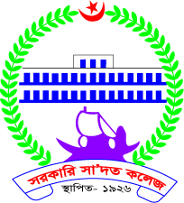
Department of English
Govt. Saadat College
Karatia, Tangail.

Date: 19/09/2023

Notice

Honours 2nd Year (Session 2020-21) Supplementary examination

This is to notify those students of Honours 2nd Year (Session 2020-21) who have failed in one or more than one subjects in the internal examination of 2022 that their supplementary examination will be held at 10:00 a.m. on 21 September 2023.

The matter is very important.

